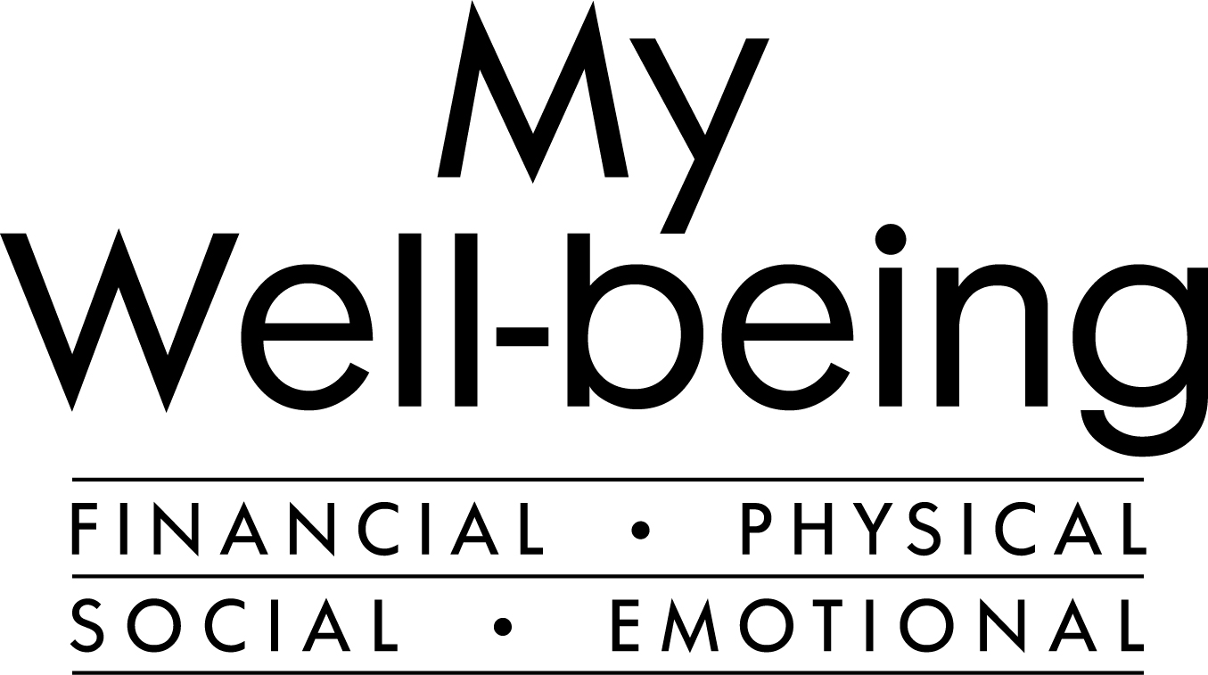 **Upcoming *My Well-being* Webinars**

**Note: You must be logged on to the Northrop Grumman network (NGGN) to view presentations via Skype.**

| **TOPIC** | **DATE/REGISTER/DIAL-IN** |
| --- | --- |
| **Mindfulness Micro-breaks**  Join NGCare each week for a guided 10-minute mindfulness practice to focus, energize and de-stress. Cultivate vitality, combat fatigue and sustain your energy with 10 minutes of instructed practice right at your desk.  Click [here](https://oursites.myngc.com/CORP/GCR/EAP/ToolKits/2021%20Mindfulness%20links/Mindfulness%20101.ics) for a 30-minute mindfulness introductory workshop. | [Tuesdays at 3:15 PM ET / 12:15 PM PT](https://oursites.myngc.com/CORP/GCR/EAP/ToolKits/2021%20Mindfulness%20links/Micro_Breaks%20At%20Work_Virtual%20Mindfulness%20Practice_Tuesdays.ics)  [Wednesdays at 12:15 PM ET / 9:15 AM PT](https://oursites.myngc.com/CORP/GCR/EAP/ToolKits/2021%20Mindfulness%20links/Micro_Breaks%20At%20Work_Virtual%20Mindfulness%20Practice_Wednesdays.ics) |
| **Bright Horizons Benefit Overview Webinars**  Your *Bright Horizons Back-Up Care*, *Bright Horizons College Coach*, and *Bright Horizons Enhanced Family Supports* benefits can help support your family’s many care and education needs.  Join an upcoming live session to learn how:   * Thursday, September 16, 3:00 p.m. ET | [**Register Now**](https://event.on24.com/eventRegistration/EventLobbyServlet?target=reg20.jsp&referrer=&eventid=2962209&sessionid=1&key=DD877DAFCA6F7F15AC946E92B2E35225&regTag=&V2=false&sourcepage=register) * Thursday, October 21, 3:00 p.m. ET | [**Register Now**](https://event.on24.com/eventRegistration/EventLobbyServlet?target=reg20.jsp&referrer=&eventid=2962285&sessionid=1&key=501854513488AB1E74D2645B4427FE3F&regTag=&V2=false&sourcepage=register) * Thursday, November 18, 3:00 p.m. ET | [**Register Now**](https://event.on24.com/eventRegistration/EventLobbyServlet?target=reg20.jsp&referrer=&eventid=2962293&sessionid=1&key=048FE1CF4B37E1762FFF383DD9C19D0D&regTag=&V2=false&sourcepage=register) * Thursday, December 16, 3:00 p.m. ET | [**Register Now**](https://event.on24.com/eventRegistration/EventLobbyServlet?target=reg20.jsp&referrer=&eventid=2962301&sessionid=1&key=50998EC026924490F42D226D7C64C113&regTag=&V2=false&sourcepage=register) | See dates and times of each webinar in the left column.  To register, click on “Register Now” (left column) to attend a specific session or access a recorded version by clicking [**here**](https://event.on24.com/eventRegistration/EventLobbyServlet?target=reg20.jsp&referrer=&eventid=2618177&sessionid=1&key=43D24220B80A9D1AAF7FA355EAF0879F&regTag=&sourcepage=register). |
| **Bright Horizons College Coach® Webinars**  Get expert education assistance from Bright Horizons®.  Take the worry out of your child’s educational future with *Bright Horizons College Coach*®*.* Your free benefit gives you access to a team of college admissions and finance experts who can help you maximize your child’s academic success and plan for college costs.    ***2021 Bright Horizons College Coach® Webinar Schedule:***  **College Admissions: The Insider’s View**  Wednesday, September 15 at 1 PM ET / 10 AM PT  **Navigating the FAFSA and Other Financial Aid Applications** Wednesday, October 20 at 12:30 PM ET / 9:30 AM PT  **The Course Ahead: Majors to Careers**  Wednesday, November 10 at 3 PM ET / 12 PM PT  **PSAT: What a Score Means, Why It Matters**  Thursday, December 2 at 3 PM ET / 12 PM PT | See dates and times of each webinar in the left column.  To attend, you must be registered for the Bright Horizons College Coach® benefit. [Click here to create your account.](https://passport.getintocollege.com/)  **First time user?** Click sign-up and enter:  Employer Username: Northgrum  Password: CARE4YOU  Already registered for Bright Horizons College Coach? [Click here to register for the webinars.](https://passport.getintocollege.com/)  Questions? Call 866-468-3126 or email  [ngc@getintocollege.com](mailto:ngc@getintocollege.com) |
| **Bright Horizons Special Needs™ Webinars**  Help Ensure Your Child is on the Right Track for a Bright Future. Find Support Through Bright Horizons Special Needs™.  Imagine your child being able to bring his or her whole self to school and knowing he or she is receiving support, overcoming challenges, and reaching critical milestones. Your free *Bright Horizons Special Needs™* benefit can help you make that vision a reality. Get the tools you need for navigating all phases of the special education journey, from diagnosis through IEPs, 504 plans, and transition to adulthood, including:   * **An interactive website** that will help you better understand, advocate for, and support your child * **Expert webinars** covering a range of social, learning, attention, and developmental challenges * **Personalized guidance** from an advisor who is matched with your family to address your child’s unique needs   ***2021 Bright Horizons Special Needs™ Webinar Schedule:***  **Finding & Keeping Friends: Strategies to Support Your Child**  Tuesday, September 21 at 12 PM ET / 9 AM PT  **Time Management for Kids and Teens With Executive Function Challenges**  Wednesday, October 27 at 3 PM ET / 12 PM PT  **Education Survival Kit for Parents**  Tuesday, November 9 at 12 PM ET / 9 AM PT  **When You Disagree With the Public School**  Wednesday, December 8 at 3 PM ET / 12 PM PT | See dates and times of each webinar in the left column.  To attend, you must be registered for the Bright Horizons Special Needs™ benefit. [Click here to create your account.](https://ngc-brighthorizons.torchlight.care/?invitation_code=CARE4YOU)  Already registered for Bright Horizons Special Needs? [Click here to register for the webinar.](https://ngc-brighthorizons.torchlight.care/?invitation_code=CARE4YOU) |
| **Fidelity: Wealth Webinar Wednesdays**  **12 PM and 3 PM ET / 9 AM and 12 PM PT**  **Take the First Step to Investing**  **September 15**  If you want to understand how to start investing: Learn key investing concepts, common investment types and how to choose your investment approach.  **Prepare for the Reality of Healthcare in Retirement**  **October 20**  If you want a better understanding of health care in retirement: Learn about the costs of health care in retirement and how you can prepare for them.  **Preserving Your Savings for Future Generations**  **November 17**  If you want information on estate planning: Learn about the components of an estate plan, including information on wills versus probate, powers of attorney, healthcare proxies, and the importance of gifting and insurance replacement strategies  **Tax Efficient Investing**  **December 15**  If you want a better understanding of how taxes can impact your investments, and how tax efficient investments, including your 401k, may help you save more to achieve your goals. | Register Now  [Fidelity NetBenefits](https://netbenefits.fidelity.com/NBLogin/?option=LiveWeb&client=727796) |
| **Bright Horizons Family Webinars & Parenting Workshops**  Join Bright Horizons® for a year of family webinars and parenting podcasts featuring practical advice on parenting, caregiving, learning, and managing your work and family life.  **Great Places for Childhood**  **September 28 at 3 PM ET / 12 PM PT |** [**Register Now**](https://event.on24.com/eventRegistration/EventLobbyServlet?target=reg30.jsp&partnerref=flyer&eventid=2866297&sessionid=1&key=214B05F0EB7BA67B0921C8C831EAE357&regTag=&V2=false&sourcepage=register)  A great childhood provides opportunities for creativity, exploration, and play; promotes positive sense of self; and offers secure, trusting relationships with adults. Learn about the benefits of quality child care—what children learn and how.  **Encouraging Empathy and Gratitude in Young Children**  **Tuesday, October 12, 12:00 p.m. ET |** [**Register Now**](https://event.on24.com/wcc/r/3033755/74BDC6CE58F506B2A9560BBB0460E579)  **Wednesday, November 17, 3:00 p.m. ET |** [**Register Now**](https://event.on24.com/eventRegistration/EventLobbyServlet?target=reg30.jsp&referrer=&eventid=3033765&sessionid=1&key=D57118CC6371671BBB8E6AB7275118D7&regTag=&V2=false&sourcepage=register)  **Thursday, December 9, 3:00 p.m. ET |** [**Register Now**](https://event.on24.com/wcc/r/3033771/FE8319D860C6671DFE6CD7AFF0ECBDE1)  Empathy and gratitude are skills that can lead a child to live a full, joyful, successful life. We’ll help you understand the milestones of empathy development, explore how to boost your child’s empathy skills, and provide strategies for helping your child when they struggle to feel empathy or gratitude.  **“What Happened to MY World?” Helping Children Cope**  **November 16 at 7 PM ET / 4 PM PT |** [**Register Now**](https://event.on24.com/wcc/r/2866298/65C44D64F44603F166B63CFA7258812F)  Children’s lives have always been marked by change. But some events put particular pressure on adults to be at their best as parents and caregivers. Learn from early childhood experts how you can support children through trauma. | See dates and times of each webinar in the left column.  Click on “Register Now” (left column) to register for one event at a time, or register once for the entire series by clicking [here](https://event.on24.com/eventRegistration/EventLobbyServlet?target=reg20.jsp&partnerref=flyer&eventid=2866211&sessionid=1&key=91B5320739FB459A5CE2DA7FB1893C0E&regTag=1894368&V2=false&sourcepage=register). |
| **Flu Awareness**  Get the scoop on the latest news with the flu and learn the difference between the flu and a cold. Find out what you can do to prevent both.  *This is webinar #3 in a 3-part Well-being Wednesdays series designed to help you build your overall physical and emotional well-being while navigating these unprecedented times of COVID-19.* | Registration is Required  [Sept. 29, 12 PM ET / 9 AM PT](https://event.on24.com/wcc/r/3240688/D3D5108858CABF25C4C11A41D09E99DD) |
| **Understanding and Treating Headaches and Migraines**  **Free ConsumerMedical Webinar**  Anyone can experience headaches, but the type, cause, and severity may vary from person to person. Although you can relieve some headaches with over-the-counter medicines, others may require prescription medications or medical care to treat. ConsumerMedical offers resources and guidance to help you understand the different types of headaches and migraines, as well as your treatment options.  Join Dr. Caitlin Fawcett from ConsumerMedical for a **free, educational webinar** covering these important topics:   * Types of headaches and migraines * Symptoms and causes * When to see a doctor   Options for treatment and prevention | Register Now  [Oct. 13, 12 PM ET / 9 AM PT](https://info.consumermedical.com/webinar) |
| **One-on-One Financial Consultation**  One-on-one phone-based financial well-being reviews with a Fidelity representative continue to be available. In this complimentary, voluntary review, you’ll discuss your goals then build a retirement plan that can help you reach them.  *Retirement well-being reviews are intended to provide a holistic overview of your retirement readiness based on the financial information and goals provided by you to the Fidelity representative. Fidelity has been instructed not to engage in solicitation or sales of products beyond those offered to you in the plan. Northrop Grumman and its employees and affiliates have not endorsed any solicitations, recommendations or offerings*. | [Register here for an appointment](https://login.fidelity.com/ftgw/Fidelity/NBPart/Login/Init?AuthRedUrl=https://workplaceservices.fidelity.com/mybenefits/employerservices/navigation) |